How to configure the Pi-hole
1 Introduction 2
2 Prerequisites 2
3 Step-by-step plan 2

Introduction
This manual is intended as guide for configuring a Pi-hole

Prerequisites
- Putty

Step-by-step plan
- SSH to 172.16.3.25 >> Username administrator | Password Vessel001!
(all passwords are set to Vessel001! By default)
- Change password of administrator, adl_tse & adl_local accordingly
Sudo Passwd administrator
Sudo passwd adl_tse

- Change the web interface password via the CLI
Pihole –a –p <password>

- Update and reconfigure so the webinterface works

- Change the DNS server to your Domain controllers IP address (in web interface)
http://pihole/admin
Login with administrator
Settings >> DNS >> change [Custom 1 (IPv4)] to IP@ of DC01

- Additional commands that might be useful
pihole –up Update Pi-hole to latest version
pihole –r reconfigure or repair Pi-hole
pihole –g update the list of ad-serving domains
pihole –h help dialog
pihole –v version

Erros

Lost Connection to API
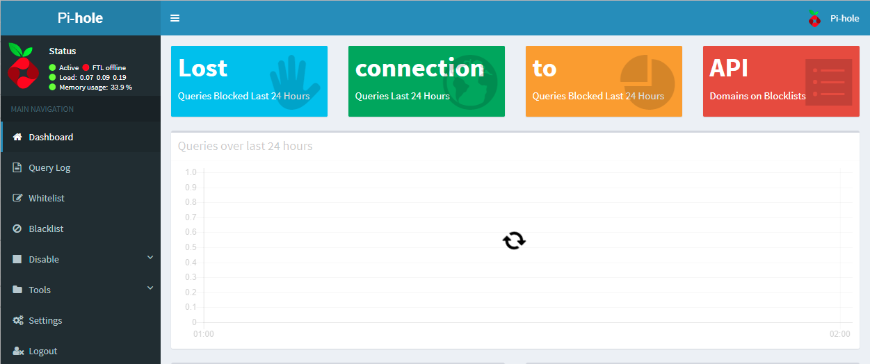

Cat /var/log/pihole-FTL.log

sudo chown pihole:pihole /etc/pihole
sudo mkdir /var/run/pihole
sudo chown pihole:pihole -R /var/run/pihole
sudo service pihole-FTL restart

Error DNS
Upgrading the current version of the pihole will make the dnsmasq service stop working. To solve this, upgrade the distro of the pihole by performing following steps

Putty to 172.16.3.25

Sudo nano /etc/apt/sources.list

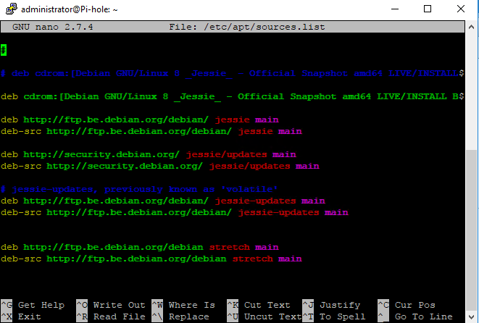

Add following lines as in the screenshot above:

deb http://ftp.be.debian.org/debian/ stretch main
deb-src http://ftp.be.debian.org/debian/ stretch main

press ctrl+X to exit en save the file (if prompted, press Y to overwrite).

Update and upgrade your current OS with following command:

Sudo apt-get update (press Y when prompted)
Sudo apt-get upgrade (press Y when prompted)

When done, upgrade the DNSMASQ service with following command:

Sudo apt-get install dnsmasq/stable

